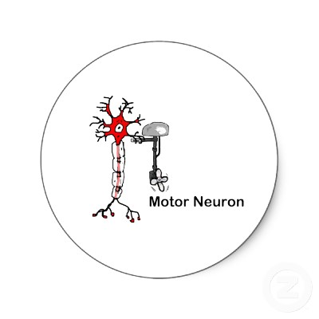
Nerves and Muscles
- ________________________________
- Definition: a neuron that transmits impulses from the ___________________
__________________________
- ___________________________________: the electrical impulse (info!)
- Axons enter muscles and send out branches to ________________________.
- _____________________________________________
- Definition: _______________________________________ between nerve cell and muscle cell
- AKA: __________________ : a more general term referring to the cell-to-cell junction
- Location: near the center of a muscle fiber
- __________________________: a single motor neuron and all the skeletal muscle fibers it ____________________________ (_______________________!)
- __________, controlled muscle may have only one or a few fibers per unit
- __________ muscles may have as many as 1000 fibers per unit
- ____________________ determined by ______ of motor units in muscle
- Structure of NMJ
- _____________________________: enlarged axon terminal
- _____________________________: space btw. presynaptic terminal and muscle fiber
- _________________________________: muscle fiber membrane
- ___________________________: small sac containing neurotransmitter
- ___________________________; chemical that axon end _____________
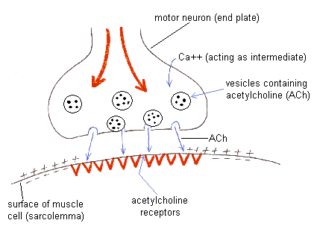
_____________________ another neuron or effector
- _________________________________: substance released from motor neuron that _______________________________________
_________________________ and innervates muscle fibers
- _____________________________________: __________________
________________________ acetylcholine to ______________
_____________________________________

