C:\Users\user\AppData\Local\Microsoft\Windows\Temporary Internet Files\Content.IE5\O8O3K7H5\MC900383746[1].wmfC:\Users\user\AppData\Local\Microsoft\Windows\Temporary Internet Files\Content.IE5\KQOAVM2F\MC900367950[1].wmfMuscle Contraction

1. Role of Actin and Myosin
2. Myosin : _____________________________________
3. Actin: _____________________________________

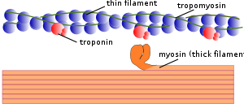

1. **Stimulus** for Contraction
2.  **____________________________** : rapid depolarization and repolarization of the cell membrane
3. **_____________________________** : change from resting membrane potential **[***charge difference* btw. the outside of the cell membrane (+) compared to the inside (-) **]**
4. **_____________________________**: *change back* to resting membrane potential
5. **Sliding Filament Theory**
6. Sliding of the thin filaments toward the center of each sarcomere quickly shortens the muscle fiber and thereby the entire muscle
7. 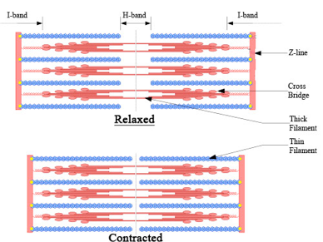Energy = ___________________________________________________