SKELETAL MUSCLE HISTOLOGY
Structure (Use with L1 p178)
1. _____________________________
a. Definition: sheet of fibrous connective tissue (CT) that encloses a muscle
b. Location: (label #79)
MAY project beyond muscle and form a cord-like tendon or intertwine with periosteum

2. ______________________________
a. Definition: ___________________________ of CT surrounding a skeletal muscle
b. Location: (label #77)

3. Muscle _______________________ [pl. fasciculi]
a. Definition: ________________ of skeletal muscle fibers (_____________) in small
compartments
b. Location: (label #71 & #78)

4. ______________________________
a. Definition: sheath of CT that ________________________________of muscle fibers
b. Location: (label #74)

5. ______________________________ (muscle fiber) (aka: ______________________!)
a. Definition: a __________________ that contracts/relaxes in response to stimulation
b. Location: (label #70 & #72)
c. Structure of cell
1) _______________________ (label #66 and see “A”)
a) Definition: ___________________________________________
b) Structure: invaginations of ______________________________________
_____________________________________________________________
( see “C” )
2) _______________________ (label #67 )
a) Definition: _________________________ of muscle cell
b) contains small, oval nuclei and mitochondria and myoglobin ( see“D”)
c) ________________ similar to hemoglobin; stores O₂ for mitochondrion
3) ______________________________________ (SR) ( see“B” )
a) Definition: membranous ________________________ and tubules w/i a
muscle fiber
b) Function: together with T-tubules, _______________________________
_____________________________________________________________
4) ___________________________
a) Definition: sheath of CT that _____________________________________
b) Location: (label #73 & 75)

5) ______________________________
a) Definition: _____________________________________________________
b) Location: (label #68 and see “E”)
c) Structure
(1) ______________________________________ ( see”H-1” )
(a) Definition: a protein in combination with actin
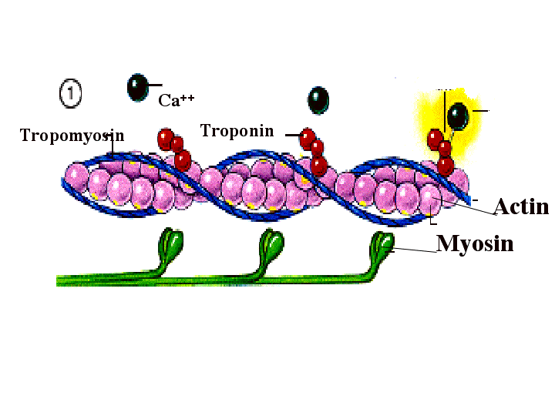
contracts and relaxes muscle fibers
(b) Location:
(c) Structure: resembles golf club with end called heads
that binds to actin to form crossbridges
(2) ______________________________________ ( see “G-1” )
(a) Definition: a protein in combination with myosin
contracts and relaxes muscle fibers
(b) Location:
(c) Structure: resembles strands of pearls made of
troponin (provides Ca ++ binding site) and
tropomyosin (located along groove btw twisted
strands)

6) ____________________________ ( see”F” )
a) Definition: ______________________________________________
of a myofibril
b) extending from z-line to z-line ( see”F-1” )
c) __________________ are dense areas of protein

7) striation pattern
a) _____________________________: ( see “G” )
- _______________________ ________, actin filaments, attached to z-line
b) _____________________________: ( see “H” )
- _______________________ ________, myosin filaments overlapping with thin actin filament
c) H- zone: ( see “J” )
- a narrow, light zone in center of sarcomere consisting of only myosin which is anchored at the M- line ( see “K”) in a dark-stained thickened band

