CH 6 MusculoSkeletal System Lesson 1
pgs. 139-150
Function First
The MusculoSkeletal System
- provides protection, support, and movement
- formation of blood cells
- storage of fat in bone marrow
- release of minerals, especially Calcium

Exercise 1 WRITE IT! p140

Structures of the MusculoSkeletal System
Major Bones of the Body

There are 206 named bones.
There are two divisions of the skeleton: axial and appendicular
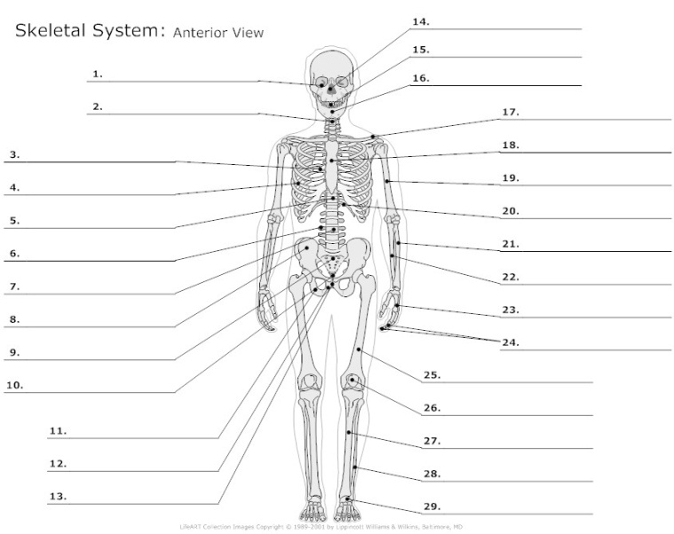

Exercises 2 MATCH IT! p143 Exercise 3 WRITE IT! p143 Exercise 4 WRITE IT! p150
Programmed Learning p143-150
Word Parts: Major Bones of the Body

Bone
Bones that form the Vertical Axis of the Body Review:
clavicul(o) hemat(o)
crani(o) -poiesis
cost(o) muscul(o)
scapul(o) orth(o)
stern(o) ped(o)
rachi(o), spin(o) -ic
vertebr(o) -al
spondyl(o) anter(o)
cervic(o) -oid
thorac(o) -graph
lumb(o) dist(o)
sacr(o) inter-
coccyg(o) proxim(o)
cardi(o)
Bones of the Upper Extremities
humer(o) in-
radi(o) micro-
uln(o) -scope / -scopy
carp(o) skelet(o)
metacarp(o) viscer(o)
phalang(o) abdomin(o)
bi-
Bones of the Pelvis
pelv(i) brachi(o)
ili(o) pector(o)
ischi(o) para-
pub(o) quadri-
-plegic
Bones of the Lower Extremities
femor(o) -itis
patell(o) my(o)
fibul(o) oste(o)
tibi(o) cutane(o)
tars(o) sub-
calcane(o) myel(o)
metatars(o) -oma
poster(o)
dys-
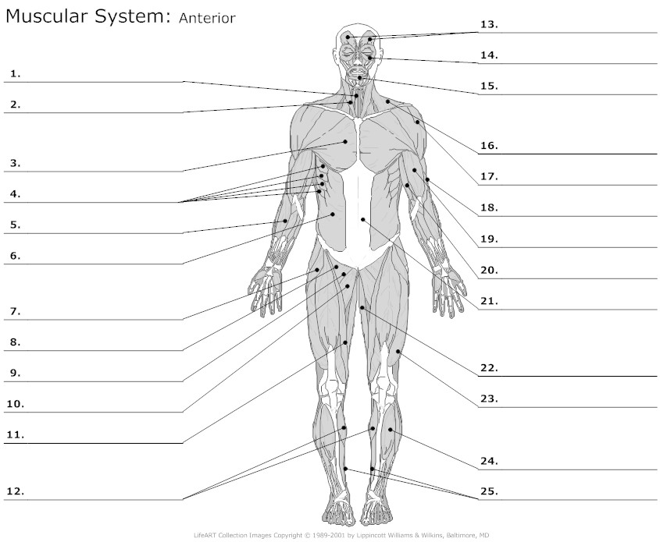

Pronunciation List

musculoskeletal cartilage
hematopoiesis chondral
orthopedics
orthopedist articulation
synovial
clavicle (-ar) bursae
cranium (-al) extension
costa (-al) flexion
intercostal rotation
subcostal circumduction
scapula (-ar) ligaments
sternum (-al)
substernal visceral
sternoclavicular involuntary
spine fascia / fascial
cerebrospinal tendons
vertebrae (-al) myelitis
intervertebral myelofibrosis
vertebrocostal / costovertebral osteomyelitis
cervical / cervix myeloencephalitis
thoracic / thorax myopathy
lumbar myolysis
thoracolumbar myalgia
sacrum (-al)
coccyx (-eal)
humerus (-al)
humeroscapular
humeroulnar
radius (-al)
ulna (-ar)
carpals / carpus
carpal tunnel
carpectomy
carpophalangeal
metacarpals
phalanges
phalangitis
ilium (-ac)
iliopubic
ischium (-al)
ischiopubic
ischiofemoral
ischiococcygeal
pubis (ic)
pelvis (-ic)
femur
patella
patellofemoral
fibula
tibia
tibialgia
tarsals / tarsus
calcaneus
metatarsals
facial
rachiodynia, rachialgia
lumbago
osteoid
calcification / decalcification

