C:\Users\user\AppData\Local\Microsoft\Windows\Temporary Internet Files\Content.IE5\KQOAVM2F\MC900280753[1].wmfCH 5 Lesson 6 Body Defenses and Immunity

p125-132

**________________________________**: being vulnerable to a disease or disorder

**________________________________**: body’s ability to counteract microorganisms or toxins

*Types* of Resistance: Non-Specific and Specific

Non-Specific Resistance **directed against ALL pathogens

Skin: __________________________________ Mucous membranes: _______________________

Eye tearing: ____________________________ Digestive: _________________________________

Urinary: _______________________________ Lymph: ___________________________________

Respiratory : _______________________________________________________________________

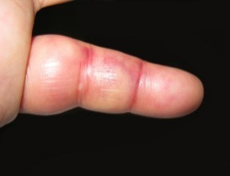*Includes*:

* _______________________________: a protective response of body tissue that increases circulation to an area after irritation or injury

symptoms: ___________________________________________________________________

_____________________________________________________________________________

* _______________________________: ingestion and destruction of microorganisms
* _______________________________: cell produced protein that protects
* _______________________________: promotes inflammation, phagocytosis, and rupture of bacteria

Specific Resistance or *SELECTIVE*

: __________________________________________________________________________________

__________________________: body’s ability to counteract effects of infectious organisms

:acquired by _________________________________________________________________

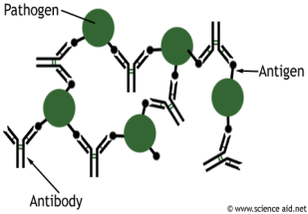Immune Reaction (antigen-antibody reaction) :_______________________________________

* ___________________: any substance that the body regards as foreign

(bacteria, virus, toxin)

* ___________________: disease fighting protein produced in response to presence of a specific antigen

______________________________: process by which resistance to an infectious disease is induced or augmented

__________________: individual’s own body produces an immune response to a harmful antigen

__________________: immune agents develop in another person or animal and then are transferred to an individual who was not previously immune

*recognition of specific antigens is called ____________________________________________

C:\Users\user\AppData\Local\Microsoft\Windows\Temporary Internet Files\Content.IE5\VSH3PEQ8\MC900279538[1].wmf__________________: individual contracting disease or fetus being exposed to maternal antibodies

__________________: deliberate action of receiving vaccinations or antibodies

_______________________: administration of antigenic material (inactivated or killed microbes or their products )to induce immunity

Examples: ______________________________________________________________________

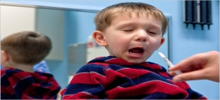:administered orally, by injection, or nasal spray

_______________________________________: person whose immune response has been weakened by a disease or _____________________________________________ (radiation or certain drugs) aka: _________________________________________________

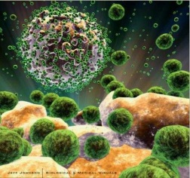_______________________________________: caused by a defect in immune system and characterized by susceptibility to infections and chronic disease

* + *AIDS* **(acquired immune deficiency syndrome) :** no cure, prognosis is poor, caused by -HIV-1 or HIV-2 (human immunodeficiency virus), transmitted by sexual intercourse or exposure to contaminated body fluid

_________________________________: excessive reaction to an antigen

_______________________: conditions in which the body reacts with an exaggerated immune response to common harmless substances (most from environment)

Examples: _________________________________________________________________

_________________________________: (anaphylactic reaction) life-threatening hypersensitivity reactions to a previously encountered antigen

C:\Users\user\AppData\Local\Microsoft\Windows\Temporary Internet Files\Content.IE5\KQOAVM2F\MC900432423[1].wmf_____________________: any disease-producing agent or microorganism including bacteria, fungi, protozoa, and viruses (types of bacteria: cocci, bacilli, or spirilla)

____________________: invasion of the body by pathogenic microorganisms that cause disease

Body Defenses: (*immune system*)

___________________: favorable for recovery; not having tendency to spread

_______________________: tending to grow worse, to spread, and possibly become life threatening (cancer cells)

_______________________: spreading from one part of body to another

_______________________: spread to sites away from where they originate

**Bioterrorism**: use of pathogenic agents to cause terror in a population

WMD____________________________________________________________________________

FEMA ___________________________________________________________________________

CDC ____________________________________________________________________________

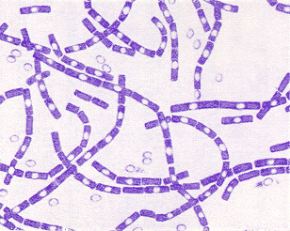*Categories:*

B ________________________________  
N ________________________________   
I ________________________________   
C ________________________________   
E ________________________________

High-priority agents include _______________________________________

Pose a risk to national security :

1. can be easily __________________________ or transmitted
2. cause __________ mortality rates and major __________________________________
3. cause public _______________ and social ____________________
4. 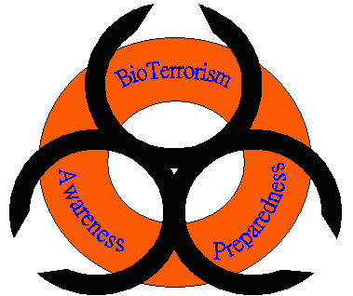require special action for public health preparedness

**bacter(i)/bacteri(o)** _____________________________

**vir(o), virus(o)** _____________________________

**strept(o)** _____________________________

**staphyl(o)**  _____________________________

**seps(o) , sept(i), sept(o)** _____________________________

**nos(o), path(o)** _____________________________

**fung(i), myc(o)** _____________________________

**-phylaxis** _____________________________

**immun(o)**  _____________________________