p84-86

endoscope
endoscopy

catheter
catheterize
catheterization

cannula

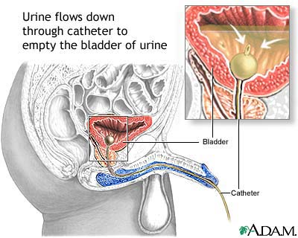
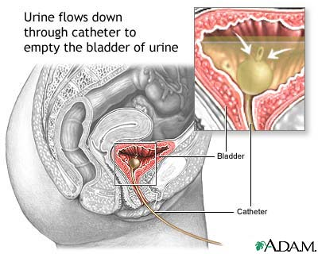
Exercise 4 BUILD IT! p84 (answers on page 408)
Exercise 5 WRITE IT! p84
Exercise 6 WRITE IT! p86

