Blood Vessels
A. ___________________________________________
1. Definition: vessel that transports blood _______________ from heart at high
pressure
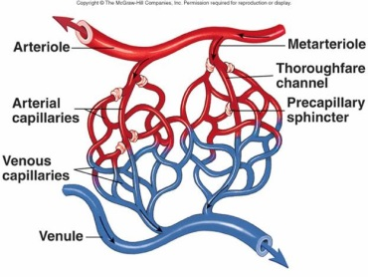
2. Types
a. ______________________________ arteries
1) largest
2) include aorta and some of its branches
3) can stretch to accommodate surge of blood as heart
contracts
b. ______________________________ arteries
1) carry blood to specific organs
2) smaller in diameter, muscular layer is proportionately
thicker
3) examples: brachial, femoral, gastric
c. ____________________________________
1) critically important in regulating blood flow
2) function by variable contraction of smooth muscle in
walls which increases resistance to blood flow and helps
to regulate BP
d. ____________________________________
1) short connecting vessels that connect true arterioles to
capillaries
2) have regulatory valves (smooth muscle =
precapillary sphincters)
B. __________________________________________
1. Structure
a. microscopic
b. more than one billion in body
c. distributed non-uniformily
d. activity ___________________________________ with tissue rate of
________________________________________
2. Function
a. carry blood ____________________________________________ (small veins)
b. exchange of nutrients and other vital substances
C. ______________________________
1. Definition: vessel transporting blood from capillaries ______________ heart
2. _____________________________
a. small-diameter, narrow lumens, and porous, this walls
b. walls are endothelial cells and a few muscle cells
3. Structure of Veins
a. larger venous channels
b. capacitance: stretch and increase capacity with no pressure change
c. ___________________: one way to keep blood moving toward the heart

D. Overall Structure
1. ________________________________________
a. provide smooth surface ______________________________________________
b. and _____________________________________________
c. have intercellular clefts which vary in size & number influencing
the diffusion of substances
2. _______________________________
a. ________________________________
1) woven together in wall to strengthen
b. _______________________________
1) secreted into extracellular matrix
2) organized into circular patterns to allow recoil
c. ______________________________________
1) not found in capillaries
2) exerts active tension
3. Layers
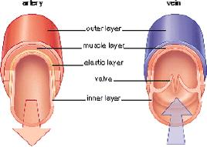
a. Tunica ______________________________
1) ____________________________, external layer
2) composed of strong, flexible, fibrous connective tissue
3) prevents tearing and anchors
b. Tunica _______________________
1) ____________________ layer
2) smooth muscle and elastic connective tissue
3) permits changes in vessel diameter
4) innervated by autonomic nerves
c. Tunica ________________________
1) __________________________ layer
2) endothelium continuous with that which lines the
heart

