THE CARDIOVASCULAR SYSTEM
A. Functions
1. aka: (along with lymphatic system) is known as circulatory system
2. transportation of materials (gases, nutrients, wastes) throughout the body
3. dependent upon the heart
B. Facts
1. develops early and reaches functional state long before any other major organ
systems
2. heartbeat begins in the _________________________________________________
3. the heart beats approximately 100, 000 times per day
C. Size and Location
1. _______________________________________________________________________
2. size of a fist (14 cm x 9 cm)
3. lies in ______________________________ just behind ___________________
4. lower border forms ____________ which directs slightly to the __________

D. Coverings of the Heart
1. ____________________________
a. outer sac, loosely fitting; tough fibrous tissue protects and anchors
b. known as ________________________________________________________
2. ____________________________
a. visceral layer (_______________________ on the heart)
b. continuous with heart wall at superior margin aka: serous pericardium
E. Wall of the Heart
1. _____________________________
a. composed of cardiac muscle tissue
b. _________________________________________ join adjacent cells
c. large areas electrically coupled into single functioning units allowing quick
conduction of action potentials for forceful rhythmic contraction
2. _____________________________
a. delicate _____________________of interior wall
b. endothelial tissue covers branched projections (________________________)
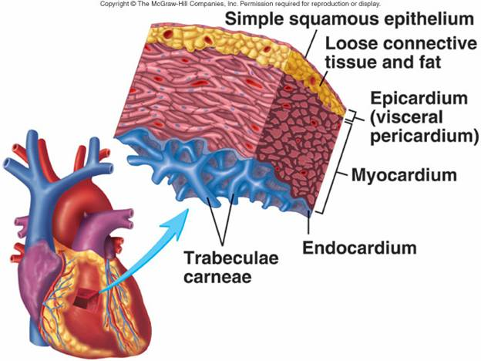
F. Chambers of the Heart
1. ________________________________
a. ____________ chambers
b. separated into right and left (interatrial septum)
c. receive blood from veins
d. ____________ walls

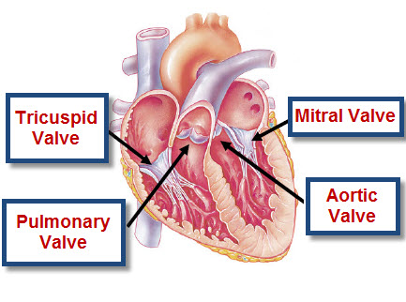
2. _______________________________
a. ___________ chambers
b. separated into left and right (interventricular septum)
c. primary pumping chambers
d. ____________ muscle

G. Valves of the Heart
1. ________________________________ Valves (AV)
a. Anchored to papillary muscles of ventricles by chordae tendinae
b. ____________________________
1) btw right atrium and right ventricle
2) three flaps
c. ___________________________ (_____________)
1) btw left atrium and left ventricle
2) two flaps
2. ________________________________ Valves (SL) (resemble half-moon)
a. ______________________________ : entrance of pulmonary artery
b. __________________________ : entrance of aorta
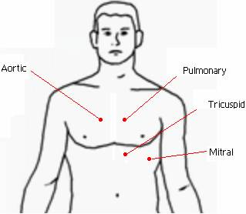
H. Auscultation Points

I. Skeleton of the Heart
1. set of fibrous connected rings
2. semi-rigid support for heart valves &
attachment of cardiac muscle
3. electrical barrier btw myocardium of atria
and ventricles

J. Vena Cavae (large veins)
1. ______________________: delivers blood from head, neck, upper limbs, & chest
2. __________________: delivers blood from rest of trunk, the viscera, & lower limbs

K. Pulmonary Vessels
1. Pulmonary ___________________________
a. take blood to lungs for gas exchange
b. dark red (________) due to ________ oxygen/high CO2
2. Pulmonary ___________________________
a. take blood to heart from lungs
b. bright ________ due to ______________________ content

L. Blood Pathway
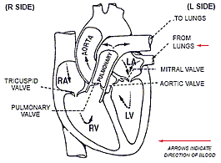

M. Blood Supply of Heart
1. __________________________________: supplies blood to muscle tissue of heart
2. __________________________________: supply blood to heart
3. _________________________ : carry blood away from coronary capillaries to sinus
4. _________________________________ : deposits to right atrium

N. Conditions
1. ________________________________
a. painful condition resulting from oxygen deprivation of myocardial cells
b. Cause: __________________________________coronary artery usually
during physical activity or emotional disturbance
c. Symptoms: heavy pressure sensation, tightening or squeezing in chest
behind sternum which may radiate to jaw, throat, upper limbs; profuse
sweating, difficulty breathing
2. _______________________________________________
complete obstruction of coronary artery or one of its branches
