Hemostasis

- Definition:
- __________________ of responses that stops bleeding when blood vessels are injured
- a ____________________
- sometimes referred to as ____________________________
[co= together agul = gluing ation = process]

- Mechanisms of Hemostasis

- Vascular Spasm
- damage causes the smooth muscle in the vessel wall to contract _________________
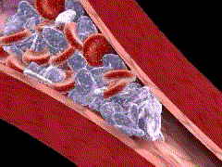
- causes _________________ blood flow
- persists from minutes to hours
- platelet attraction enhances this!

- Platelet Plug Formation
a. platelets stick to _________________________ forming a mass or plug
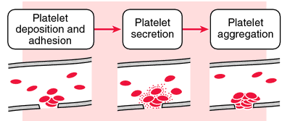
b. Aka: _____________________________
c. ____________________ inhibits aggregation at other sites
d. occurs mostly in arteries

- Coagulation
- Aka: ___________________________
- a complex process of stopping blood flow
- series of chemical reactions that __________________________________________
___________________________________________________
- prevents ______________________________

- General Events
- ________ : phospholipid that coats surface of platelets and interacts w/ TF, vitamin K, Ca++, and others
- _____________________________ produced by platelet cells and damaged tissue
- Factor X activated
- _______________________________ (enzyme) produced
- Prothrombin _________________ ________________ (another enzyme)
- Thrombin stimulates ______________________________________________ mesh
- _________________________________________________
- Pathways
- ___________________ Clotting Pathway
- rapid, within seconds
- tissue _________________________ released resulting in formation of
___________________________________
- ___________________ Clotting Pathway
- more complex
- factors activate each other

- Blood Clot
- _______________ of thread-like protein fibers; traps blood cells platelets and fluid
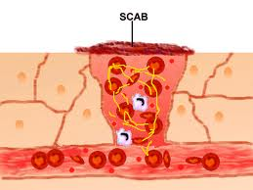
- Clot : ______________ of insoluble protein fibers = _________________
- Serum
  - ______________ w/ no fibrinogen or clotting factors
  - ____________________ liquid
- Help stop blood flow, reduce infection and enhance healing

- Blood Clot Control
- Formation occurs locally due to circulating anti-coagulants ___________________________, __________________,
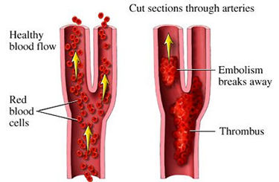
and _____________________________
- _______________________ attached
- _______________________ traveling

- Blood Clot Retraction
- consolidation or tightening of fibrin clot
- pulls edges of the damaged vessel closer
together, decreasing further damage
- ___________________ form connective tissue;
new endothelial cells repair the vessel lining
- ____________________, an inactive plasma enzyme, is incorporated into the clot
- body and blood tissues contains substances that can ________________________
________________________________which helps dissolve the clot by digesting fibrin threads

- Clot Eradication
- Healing over 2-10 days
- Tissue plasminogen activator (TPA) causes _____________________ of plasminogen
- _______________________________________________
- _________________________ proteins w/i clot

- Bleeding Disorders
- _________________________________
- __________________________________
- __________________________________
- __________________________________

