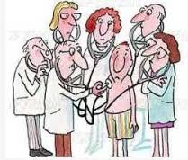
What do you know about “doctoring” ?

(PE) ________________________________________________
an orderly evaluation of body/ functions

Techniques: inspection
palpation
auscultation
percussion

(VS) ________________________________ : (include)_________________________________

________________________________________________________________________________

Types of PE
medical / clinical / “physical”
preventative
sports
insurance

Includes:
___________________________________________ : collecting info about patient (_____)
- events that might be related
- chief complaint (_____)
- history of present illness
- past medical problems
- family problems
- social history

___________________________________________ : Chemistry panel (___________________ _________________________________..) Pathology

___________________________________________:
- MRI
- CT / CAT
- X-rays
- SPECT
- PET
- Sonography

Tools

Basic Vocabulary

__________________________________ : an abnormality of structure and / or function

________________________________ : illness characterized by a recognizable set of symptoms and signs

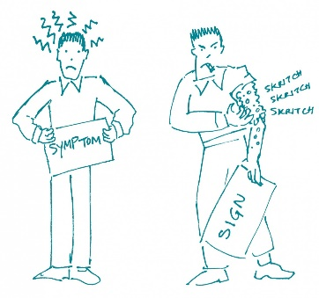
____________________________________ (_____) : changes in body functions (subjective!) not apparent to an observer
examples~

_______________________________ : objective changes, observable and measurable
examples~

__________________________________ (____) : __________________________________ of a disease or disorder based on a scientific evaluation of patient’s symptoms and signs, medical history, physical exam, and sometimes data from test

_________________________________ : a ________________________ of the probable course and outcome of a disease; the likelihood of recovery from a disease

