Additional Word Parts: MusculoSkeletal System

Combining Forms Review:
ankyl(o) -trophy
arthr(o) -cele
burs(o) -ptosis
calc(i) later(o)
cellul(o) rheumat(o)
chondr(o) poly-
ten(o), tend(o), tendin(o) hyper-
-emia
Suffixes endo-
-asthenia synovi(o)
-sarcoma an-
cerebr(o)
Prefixes esthesi(o)
de- -centesis
meta-

Exercise 5 MATCH IT! p151

Cartilage
- specialized type of connective tissue that is elastic but strong
- forms major portion of embryonic skeleton (much is later replaced by bone)

Exercise 6 FIND IT! p151

Articulations and Associated Structures
- articulation = joint
- synovial = examples: elbow, knee, ankle, shoulder, hip
- joint motion: extension, flexion, rotation, circumduction

Muscles and Associated Structures
- composed of cell or fibers that contract allowing for movement of an organ
- tissue: skeletal, smooth, cardiac
Exercise 7 WRITE IT! p154
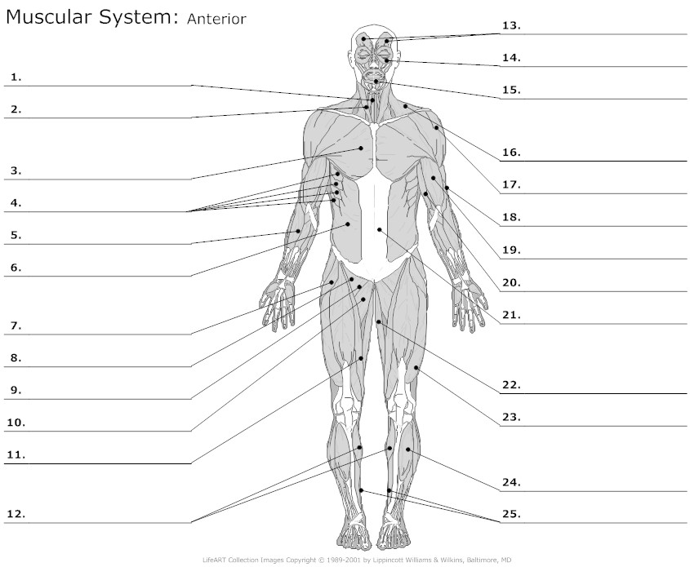

Pronunciation List

chondral synovium
articulation synovial
bursae extension
flexion rotation
circumduction ligaments
visceral involuntary
fascia / fascial tendons
musculofacial costochondral/chondralcostal
myopathy subchondral
myolysis
myalgia

